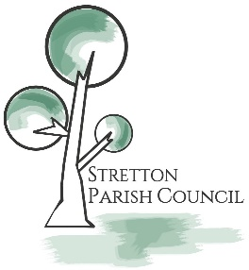
Application Form
Please complete the following job application form to be considered for employment.
Personal Information
Full Name
Address
Phone Number
Email Address
Date of Birth
National Insurance Number

Employment Information
Desired Job Title
Availability | Full-time / Part-time / Other

Education
Highest Level of Education Completed
Name of Institution
Dates Attended
Degree or Certification Earned

Work Experience for Last 3 Jobs
Name of Current Employer
Dates of Employment
Job Title
Job Duties and Responsibilities
Reason for Leaving

Name of Employer
Dates of Employment
Job Title
Job Duties and Responsibilities
Reason for Leaving

Name of Employer
Dates of Employment
Job Title
Job Duties and Responsibilities
Reason for Leaving

References
Reference 1: Name, Job Title, and Contact Information
Reference 2: Name, Job Title, and Contact Information
Reference 3: Name, Job Title, and Contact Information

Skills and Qualifications
Skills that would be relevant to the job applied for
Language Skills
Interpersonal Skills

Additional Information
Additional Information
Have You Ever Been Convicted of a Crime?

Acknowledgment and Signature
Applicant's Signature
Date
I certify that the information provided on this application is true and complete to the best of my knowledge. I understand that any false statements may disqualify me from employment, or result in termination if I am already employed.

Please send completed forms to:
Stretton Parish Council
c/o 22 Field Rise
Burton on Trent
DE13 0NR
If you have any questions or concerns, please contact: Amanda Smith - clerk@stretton-pc.gov.uk - 01283537939

